Accepted custom furniture melamine kitchen cabinet

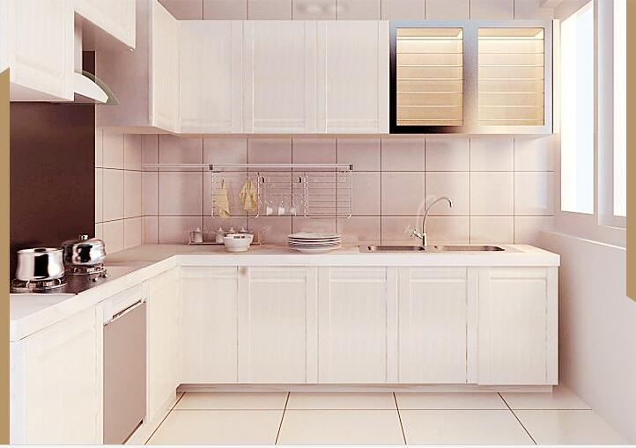
FOB Price: | US $200 - 550 / Set | Get Latest Price
Min.Order Quantity: | 1 Set/Sets kitchen cabinet
Supply Ability: | 3000 Set/Sets per Month kitchen cabinet
Port: | Qingdao
Payment Terms: | L/C,T/T,Western Union

Quick Details
- Type: Kitchen Cabinets
- Place of Origin: Shandong, China (Mainland)
- Brand Name: Elance Furniture.co.Ltd.
- Model Number: MELAMINE KITCHEN CABINETS
- Accessories: Backsplash, Drawer Basket, Drawer Slide, Faucet, Handle & Knob, Hinge, Lazy Susan Storage, Rice Box, Sink, Toe Kick, Waste Container
- Style: Modern
- Carcase Material: MDF, Melamine Board, Particleboard, Plywood
- Door Material: MDF, Melamine Board, Particleboard
- Door Panel Surface Treatment: PVC Membrane
- Cabinet Type: Modular Kitchen Cabinets
- Countertop Material: Artificial Granite, Artificial Marble, Artificial Quartz, HPL / HPDL
- Countertop Edging: Beveled Edge, Flat Edge / Eased Edge, Full Bullnose
- Color: by your request
- Material: MDF board + melamine
- Size: Customized Size
- Feature: Environmental Friendly
- Warranty: 1 Year
- style: modern/classic
- brand: Elance Furniture.co.Ltd.
- OEM service: YES
- usage: kitchen
- Product name: kitchen cabinet

Packaging & Delivery
Packaging Details | kitchen cabinet  1. flat package with bubble wrap by carton  2.as the customers requirement
Delivery Time | 25-35 days after get deposit
Product Description
Kitchen cabinet design : UV kitchen cabinet design,wood veneer melamine kitchen cabinet design, PVC modern kitchen cabinet designs ,Lacquer modular kitchen cabinet designs, acrylic kitchen cabinet design.
Type | Kitchen cabinet
Carcass material | 16/18mm chipboard or plywood
Door panel | 16/18mm MDF board
Surface finish | melamine, PVC, lacquer, HPL, UV
Countertop material | man-made stone, Quartz stone, Granite stone, marble
Accessories | soft close hinges, 3-section drawer sliding system, handle, toe kick
Style | Modern/Modular

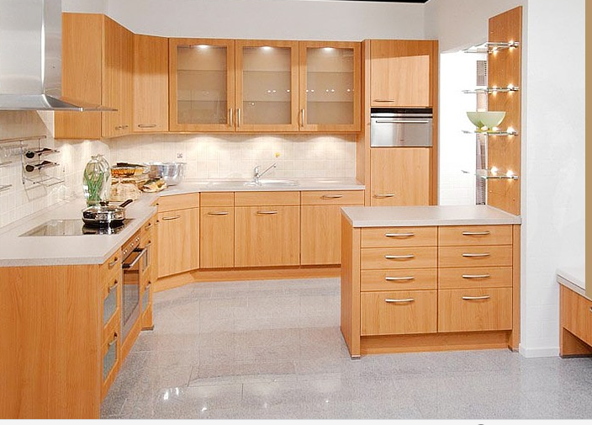
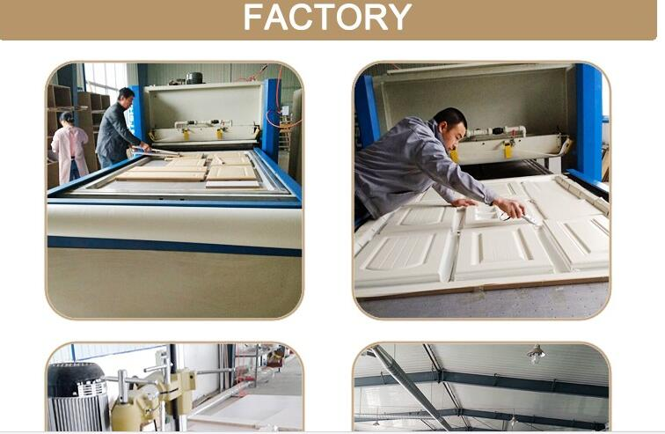

Accepted custom furniture melamine kitchen cabinet, View kitchen cabinet, Product Details from Elance Furniture Co., Ltd.
"Accepted custom furniture melamine kitchen cabinet,High Quality kitchen cabinet,kitchen cabinet MELAMINE KITCHEN CABINETS Details, Elance Furniture Co., Ltd."
"Accepted custom furniture melamine kitchen cabinet,US $ 200 - 550 / Set, Kitchen Cabinets, Shandong, China (Mainland), Source from Elance Furniture Co., Ltd."

Contact us:

Melinda Wong

E-mail: inquire@elancefurniture.com

ELANCE FURNITURE CO.,LTD
168 FENHE ROAD, DONGYING,SHANDONG 257091 CHINA
www.elancefurniture.com

